Autumn Term
Key Theme | Autumn 1 – All about me | Autumn 2 - Transport
Key Theme | 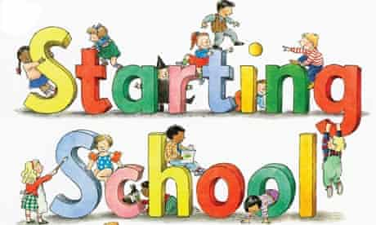  Myself, my home & family, my town and country, people who help, buildings & architects, sense of belonging. | 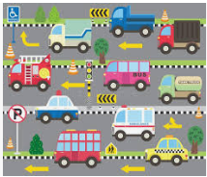  Modes of transport, other machines and their purpose, inventors and engineers.
C & L  Communication & Language | - Listen to others in 1:1 or small groups e.g. circle times about ourselves and our lives talking about interests, family dynamic, getting to know you and sharing pictures with the class  - Join in with familiar stories and rhymes e.g. nursery rhymes and familiar stories, call and response games to develop auditory discrimination skills  - Memory games  - Understand the classroom rules and school routines i.e. appropriate use of objects and tools in the classroom, acceptable behaviour during child-initiated learning. Do the children know what tools should be selected to write a letter or create a junk model?  - Respond to multi step instructions e.g. first put your coat on, zip them up and line up for playtime.  - Retell past events from stories and from own experiences in chronological order; e.g. describing a day at school, what happened at the weekend, summarizing a narrative.  - Learn new vocabulary that is subject specific and use it in new conversations with others i.e. using body part words to describe facial features such as eyebrows, eyelashes and nostrils rather than eyes and nose.  - Extending children’s thinking in their play such as “You’ve thought really hard about building your tower, but how will you stop it falling down?” | - Talk about the machines and household appliances they have in their kitchen  - Listen carefully to each other  - Find out how to safely turn machines on and off to make them work  - Learn about the importance of using household appliances safely  - Begin to explain what household appliances, such as toasters do and how they work  - Participating in small group and 1:1 discussion  - Talking about what machines they know  - Talking about what machines they have at home and explaining what they do  - Thinking of solutions to carry out the job if that machine broke i.e. the hoover or the lawn mower
PSED  Personal, Social & Emotional Development | Focus Question – Who am I? Who is my family?  - Introduce the classroom and school rules – Class dojo reward system, behaviour chart etc,  - Feelings and zones of regulation; Words to describe feelings and help to identify which zone they are in. What can I do to get back in the green zone to feel happy and calm; self-regulation techniques.  - Understand what makes them angry or upset? What can we do next time? How can we solve the problem to make it okay?  - Who am I? | - Thinking about the perspective of others during discussions about the past when technology wasn’t as advanced as today. How did people used to do things?  - Explain if this would have been difficult, suggest what they did without machines that we have to help us today.  - Cooperate with each other and take turns when making snacks
Ten:Ten  RHE Programme | Relationship and Health Education for Catholic primary schools  A fully-resourced scheme of work in Relationships and Health Education (RHE) for primary schools. Links to the PHSE/UTW – P&C Aol in the EYFS Curriculum  Module 1 – Created and loved by God
Ten:Ten  RHE Programme | Unit 1: Introduction to PE | Unit 2: Introduction to PE
PD  Physical Development  Gross Motor | Introduction to PE    - Physical: run, jump, hop, skip, balance, crawl, catch, throw  - Social: share, communication, work safely, co-operation, leadership  - Emotional: independence, perseverance, confidence  - Thinking: select and apply actions, comprehension, reflection, make decisions
PD  Physical Development  Gross Motor | Children have a range of opportunities for Physical development throughout the school day and week. They are able to experiment moving in a range of ways, safely and with control and co-ordination  Big Bikes, Outdoor Physical Equipment – rope swing, logs, tyres crates planks etc are available during CP for children to follow own interests.
Fine Motor | - Using small tools; cutlery, tweezers, pipettes, threading, cutting paper, card, fabric, tracing using templates, playdough, pegs, finger gym, dough disco.  - Pencil control  - Letter formation; through daily phonics lessons | - Using small tools; cutlery, tweezers, pipettes, scissors, drawing maps, manipulating transport, junk modelling vehicles.  - Pencil control  - Letter formation; through daily phonics lessons  - Manipulating vehicles and creating patterns with the wheels  - Screws, nuts and bolts to create vehicles
Literacy  Key Texts: | 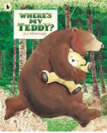  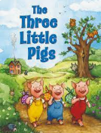  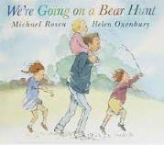  Additional Suggestions  - I am too Absolutely Small for School by Lauren Child  - Hairy Maclary from Donaldson’s Dairy  - Owl Babies  - Little Bear Lost  - Goldilocks and the Three Bears  - Where’s My Teddy?  - Ruby’s Worry by Tom Percival  - Peepbo by Janet and Alan Ahlberg  - A Great Big Cuddle (poetry) by Michael Rosen  - The Gingerbread Man  - Goldilocks and the Three Bears  - Other texts about myself, identity, family, sense of belonging, feelings | 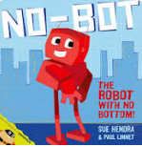  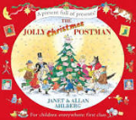  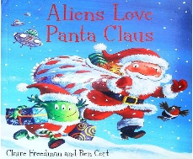  Additional Suggestions  - Car, Car, Truck, Jeep  - You Can't Take an Elephant on a Bus  - The Way Back Home  - Tom’s Magnificent Machines by Linda Sarah  - The Three Little Pigs  - The Billy Goats Gruff  - The Naughty Bus  - The Christmas Story  - The Story of Diwali
Word Reading | - Recognising initial sounds in words i.e. a, a, apple – apple begins with an a etc.  - Recognising the single letter sounds using the picture clue then just the grapheme  - Follow the ‘Strong start in Reception guidance’ from RWI  - Oral blending – Fred Games  - Practising flashcards to read single letters speedily | - Instant recall of the ‘single letter sounds’ speedily  - Some recognition of the set 1 special friends  - Beginning to blend independently using magnetic trays and letters  - Beginning to read simple cvc words in the pocket chart with support  - Some children beginning to read simple cvc words independently using the green words  - Some children moving to the Ditty/Red groupings
Comprehension | - Talk about stories and make connections with events in their own lives or other familiar stories.  - Who do they live with?  - Where is their street?  - What is their address and house number? | - Listening to new stories carefully  - Retelling stories in own word  - Answering questions correctly about the key parts and characters  - Working in pairs to recall things from the stories or texts they have been read
Opportunities for Mark making/Writing | - Representing name and initial letter sounds.  - Dominant hand, tripod grip, mark  - making, giving meaning to marks and  - labelling. Writing initial sounds and simple  - captions. Use initial sounds to label characters  - / images.  - Writing Names and Labels.  - Writing messages  - Practising correct letter formation. | - Writing CVC words  - Name writing  - Labelling using initial sounds  - Story scribing  - Retelling stories in writing area  - Sequencing the story  - Practising correct letter formation
Mathematics | WRM Units:  - Getting to know you  - Just like me  Other links:  - Counting, recognising and writing numbers in a range of practical situations including role  play, child-initiated play and adult led activities.  - Secure one to one correspondence; scaffold learning by modelling how we count objects by placing our finger on each one.  - Verbally count to and back from 10 and then 20 when appropriate.  - Numbers within 5; including subitise (recognise quantities without counting) up to five  - Number games, pattern games, ongoing mathematical provision for independent choice including numbers in sand tray, clocks, money etc | WRM Units:  - It’s me 1, 2, 3!  - Light and Dark  Other links:  - Using shape to design robots  - 2D and 3D shapes to junk model talking about basic shape names and language around shape property  - Create an adding machine  - Exploring the buttons on calculators  - Adding and subtracting on and off the bus  - Creating numicon robots on the numicon plates
Understanding the World – UTW
Past and Present - History | History: Family  - Can talk about themselves and their family  - Can talk about different occupations  - Can sequence family members  - Understands and uses language that relates to past and present  - Talk about their old baby toys | - Guy Fawkes – Why do we celebrate Bonfire night  - Machines then and now  - Transport through the ages
People and Communities – Geography | - Navigating the classroom to find items  - Treasure hunt  - Looking at Rawmarsh as the local area | Geography- Place  - Can talk about the country that they live in (Locate UK on a map- we live in England), weather, seasons)  Can explore the globe  Talk about places they have visited and what transport they used.
The Natural World  - Science | - Our bodies  - Being Healthy and taking care of ourselves  - Morning and night time routines | - Autumnal Changes  - Exploring the Autumn and Winter changes outdoors  - How far will things travel  - Travelling over land, sea and air  - Floating and sinking  - Investigating light
Come and See – Catholic Primary Religious Education Programme | Domestic Church - family | Baptism/Confirmation - belonging | Advent/Christmas - loving
 | - God knows and knows each one  - God’s love and care for every family | - Baptism  A welcome to God’s family | - Looking forward to Jesus’ birthday  - Nativity story
Expressive Arts and Design- EAD | - Drawing pictures of myself using mirrors  - Drawing pictures of my family  - Thinking about colours and using them appropriately in my pictures  - Using a range of objects to print with e.g. shoes, hands  - Learning new songs to help me in my learning  - Roleplaying in the home corner  - Acting out stories with puppets  - Using a range of materials to make collages and models  - Pablo Picasso- Self-Portrait – How does the picture reflect the mood and feeling zone that Frida was in?  - Collage- paper plate bear  - Sculpture- clay troll | - Make simple snacks using machines  - Take photographs of the machines they use  - Listening to the different sounds of machines  - Exploring instruments and vocal noises to imitate machines or engines  - Creating patterns and rhythm patterns to create machine music  - Designing robots  - Painting landscapes of the Poppy fields  - Autumn Artwork  - Printing- firework picture  - Designing a pop-up Christmas card  - Diwali card
Festivals and Celebrations | - Harvest Festival  - Any children’s birthday in Sept/October | - What is Diwali?  - Guy Fawkes  - Remembrance Sunday  - Diwali  - St Andrew’s Day  - Advent + Christmas  - Hanukah
Potential Trips/visitors | - Local area walk  - Any people who help within the community; police, nurses, fire service etc | - Transport museum, local attraction with historical transport.  - Links to local places of worship  .
Other special events | - New Parent Workshop – Introduction to phonics and supporting Early Reading  - Parents evening to talk about the initial settling and assessment. What are the next steps? How can we both support the child’s development? | - Black History Month  - St Andrews day (30th November)  - Christmas Nativity Performance  - Christmas Fayre  - Christmas dinner and jumper day  - Santa Dash

