Autumn Term
Key Theme | Spring1 – past & present | Spring 2 – The Farm
Key Theme | This project teaches children about how they have grown and changed since they were babies and how different the past was from today. | This project teaches children about food and farming and explores themes, including where food comes from, what plants and animals need to grow and survive and what constitutes a healthy life style.
C & L  Communication & Language | - Build up vocabulary that reflects knowledge and experience e.g., children can talk about  - space, what they know about it, what an astronaut does, how we know about space  - • Use different tenses to discuss things that are happening now and things that happened in  - the past, and things that happened a very long time ago.  - • Ask relevant questions to find out more information e.g., when sharing a non-fiction text  - children can say ‘I wonder why…’  - • Share opinions, explaining preferences e.g. My favourite planet is… because… | - This project teaches children about food and farming and explores themes, including;  - Where food comes from  - What plants and animals need to grow and survive  - What constitutes a healthy lifestyle?  - Looking at the person who is speaking makes it easier to listen to them.  - There are different ways to start a conversation, such as sharing your thoughts or ideas with others.  - Conversations can be continued in many ways, such as by adding to what has been said, asking or answering a question.  - Hearing your name can mean that important information will follow.  - at the person who is speaking makes it easier to listen to them.  - There are different ways to start a conversation, such as sharing your thoughts or ideas with others.  - Conversations can be continued in many ways, such as by adding to what has been said, asking or answering a question.  - Hearing your name can mean that important information will follow
PSED  Personal, Social & Emotional Development | - All families are special and different. They are different sizes and have different family members. | - Healthy diets to help us grow; what we need to eat, how we look after our bodies and keep ourselves clean including oral hygiene.
Ten:Ten  RHE Programme | Relationship and Health Education for Catholic primary schools  A fully-resourced scheme of work in Relationships and Health Education (RHE) for primary schools. Links to the PHSE/UTW – P&C Aol in the EYFS Curriculum  Module 2: Created to Love Others  Created to Love Others explores the individual’s relationship with others. Building on the understanding that we have been created out of love and for love, this Module explores how we take this calling into our family, friendships and relationships, and teaches strategies for developing healthy relationships and keeping safe both online and in our daily lives.
Ten:Ten  RHE Programme | Unit 1: Religious Understanding  Unit 2: Personal relationships | Unit 3: Life online – Internet Safety  Unit 4: NSPCC – Pants Rule
PD  Physical Development  Gross Motor | Unit 1: Ball skills    - Physical: roll, stop a rolling ball, throw, balance, catch, dribble with feet, kick, balance  - Social: work safely, collaboration, co-operation, support others  - Emotional; perseverance, independence, honesty  - Thinking; use tactics, comprehension | Unit 2: Ball skills    - Physical: roll, track, throw, dribble with hands, dribble with feet, kick, catch, balance  - Social: co-operation, take turns, work safely, communication  - Emotional: perseverance, independence, determination, honesty  - Thinking: comprehension, use tactics
PD  Physical Development  Gross Motor | Children have a range of opportunities for Physical development throughout the school day and week. They are able to experiment moving in a range of ways, safely and with control and co-ordination  Big Bikes, Outdoor Physical Equipment – rope swing, logs, tyres crates planks etc are available during CP for children to follow own interests.
Fine Motor | - Small tools; cutlery, tweezers, pipettes, scissors  - Drawing and painting | - Small tools; cutlery, tweezers, pipettes, scissors. Cutting shapes e.g., spirals  - Drawing and painting plants and flowers, leaf rubbings, pencil control
Literacy  Key Texts: | 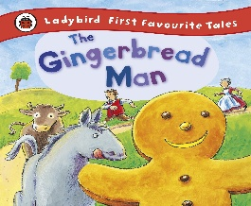  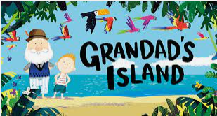  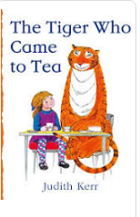  Additional Suggestions  - Chapatti Moon  - A range of non-fiction books showing things from the past  - History books of what familiar places in Rawmarsh used to look like – Children can talk about similarities, differences and what features they recognise | 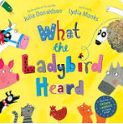  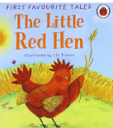  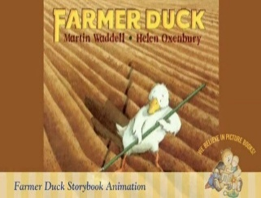  Additional Suggestions  - The very hungry caterpillar  - Rosie’s Walk  - Handa’s Surprise  - Oliver’s vegetables  - The Tiny Seed  - Non-fiction books about being healthy and keeping fit
Word Reading | - Blend sounds to read words  - read short Ditty stories | - Read Red Storybooks
Comprehension | - Fiction is a story or book about imaginary events and characters.  - Non-fiction is a text or book about real facts, people and events. Books often have unfamiliar words in them. | - A story is an account of something that happened that can be true or made up.  - Stories can be retold using simple words and props.  - Demonstrate understanding of what has been read to them by retelling stories and narratives through role play and small world play, using some key vocabular
Opportunities for Mark making/Writing | - Writing simple CVC words containing set 1 sounds  - Use initial sounds to label characters / images.  - Writing Names and Labels.  - Writing messages  - Practising correct letter formation. | - Writing simple CVC words containing set 1 sounds  - Use at least initial sounds to label characters / images.  - Writing first name independently from memory  - Writing messages  - Practising correct letter formation.
Mathematics | WRM Units:  - Alive in 5!  - Growing 6,7,8  Other links:  - Quantity; more and less in different contexts including physical objects such as counters, capacity of containers, money and numbers e.g. how many cubes can fit in this box? Can we fit more in this bigger box? How many more can we fit?  - Numbers within 20; automatic recall of number bonds to 10, secure understanding of numbers between 10 and 20, recognise the value of 10. | WRM Units:  - Building 9 & 10  - Consolidation of Spring term skills  Other links:  - Seasons in a year  - Counting to 20 and beyond i.e. children in a line  - Positional language; games where children move objects around and describe their position.  - Verbally count to 20 and beyond.  - Time to the hour and beyond; make clocks with cardboard and a split pin.  - Addition and Subtraction with numbers to 20 using concrete objects to support  - understanding.  - Odd and even numbers; using concrete objects such as numicon to support understanding.
Understanding the World – UTW
Past and Present - History | - Recognise and begin to talk about how their lives have changed as they have grown.  - Then and Now – Who’s who? What is different? What is the same? How have you changed over time?  - Shops, toys, vehicles from the past  - Looking at different sources i.e. black and white photographs | - Put familiar events in chronological order, using pictures and discussion.  - Encourage use of language relating to time, such as 'first', 'then', 'next' and 'after that' as they talk about their experience and favourite activities from the observations made.
People and Communities – Geography & RE | - All families are special and different. They celebrate different events in different ways.  - Describe ways to look after the immediate environment.  - Discuss how the local environment has changed over time using photographs and first-hand experiences. | - This project teaches children about the global community to which they belong and explores how living things, communities and climates differ around the world.  - Farming in our local area; what crops are grown where we live? Identify fruit and vegetables that can be grown locally, or within the local region.  - Identify where the fruit and vegetables we eat come from. Including but not limited to:  - Oranges: Spain  - Bananas: Central America  - Lemons: South Africa  - Pineapples: Costa Rica  - Apples: France  - Onions: The Netherlands  - Cauliflower: Spain  - Broccoli: The UK
The Natural World  - Science | - Change of materials- water turns to ice  - Play dough making  - Baking  - Liquid to solids | - Describe some ways that animals should be cared for in order for them to survive. Features of animals- fur, scales, four legs.  - Seasons of the year: Spring. The first signs of spring; snowdrops, cherry blossom, buds and flowers, birds nesting, bees, lighter evenings
Come and See – Catholic Primary Religious Education Programme | Local Church - Community | Eucharist - relating | Lent/Easter - giving
 | - What a celebration is?  - How the family parish celebrate? | - How and why people gather together?  - The joy of gathering together to celebrate at mass | - Spring is a time when things begin to grow  - Lent – Is a time to grow in love to be more like Jesus and to look forward to Easter
Expressive Arts and Design- EAD | - Mixing shades of grey using black and white paint  - Sewing – using buttons and hessian  - Explore, build and play with a range of resources and construction kits with wheels and axles. | - Naming primary colours  - Mixing primary colours  - Fruit and vegetable printing technique
Festivals and Celebrations | - Chinese New Year  - St Valentine’s Day  - Shrove Tuesday | - Easter  - Lent
Potential Trips/visitors | - A significant person from History talk i.e. Florence Nightingale  - Old Toy/new toy workshop  - Visit a museum | - Visit a farm or  - Mobile farm in to school  - Eggs/frog spawn/caterpillars to show the lifecycle of a living creature
Other special events | - Valentines Day  - St Patricks Day | - St Patricks Day  - Mothering Sunday

