Summer Term
Key Theme | Summer 1 – once upon a time | Summer 2 – The seaside
Key Theme | This project teaches children about the world of stories, developing skills in communication, literacy, critical thinking, and creativity through traditional tales like Goldilocks and the Three Bears and Jack and the Beanstalk. Children learn to listen, recall, retell, and act out stories, fostering empathy, imagination, and an understanding of different scenarios and perspectives. | This project teaches children about seaside environments and their features, such as animals, plants, and sand. Children also learn about related historical aspects, like past beach holidays, and importantly, how to stay safe at the beach and protect the environment.
C & L  Communication & Language | - Build up vocabulary that reflects knowledge and experience  - Children can use new story-related words (forest, cottage, porridge, giant, beanstalk) and connect them with what they know from their own experiences (homes, food, gardens).  - Use different tenses  - Children can talk about events in the story using past, present, and long-ago tenses.  - Now: “Goldilocks is running away.”  - Past: “She ate the porridge.”  - A long time ago: “A long time ago, people lived in castles.”  - Ask relevant questions  - While exploring stories, children can wonder aloud:  - “I wonder why Jack climbed the beanstalk?”  - “I wonder what the bears will do when they see Goldilocks?”  - Share opinions and preferences  - Children can express likes and dislikes, explaining their thinking:  - “My favourite character is the giant because he is big and loud.”  - “I like Baby Bear best because he is kind.” | - Build up vocabulary related to the seaside (e.g., waves, shells, lifeguard, bucket, spade, tide, pier).  - Use different tenses when talking about experiences:  - Now: “The waves are splashing.”  - Past: “I went to the beach and built a sandcastle.”  - Long ago: “A long time ago, people wore different clothes to the beach.”  - Ask and answer questions to find out more:  - “I wonder why the sea moves in and out?”  - “How do crabs hide in the sand?”  - Share opinions and preferences:  - “My favourite thing at the beach is collecting shells because they are colourful.”  - “I like the sea best because I can splash in the waves.”  - Develop listening and conversation skills:  - Looking at the person speaking, taking turns in conversation, and adding ideas or questions to keep discussions going.
PSED  Personal, Social & Emotional Development | - Understanding feelings  - Developing empathy and kindness  - Building confidence  - Managing behaviour and resolving conflict  - Forming positive relationships | - Understanding feelings  - Developing empathy and kindness  - Building confidence  - Managing behaviour and keeping safe  - Forming positive relationships
Ten:Ten  RHE Programme | Relationship and Health Education for Catholic primary schools  A fully-resourced scheme of work in Relationships and Health Education (RHE) for primary schools. Links to the PHSE/UTW – P&C Aol in the EYFS Curriculum  Module 2: Created to Love Others  Created to Love Others explores the individual’s relationship with others. Building on the understanding that we have been created out of love and for love, this Module explores how we take this calling into our family, friendships and relationships, and teaches strategies for developing healthy relationships and keeping safe both online and in our daily lives.
Ten:Ten  RHE Programme | Unit 1: Religious Understanding  Unit 2: Personal relationships | Unit 3: Life online – Internet Safety  Unit 4: NSPCC – Pants Rule
PD  Physical Development  Gross Motor | Unit 1: Dance    - Physical: actions, dynamics, space, balance, jump  - Social: work safely, respect, collaboration  - Emotion: independence, confidence  - Thinking: select and apply actions, creativity, exploration, recall, provide feedback | Unit 2: Dance    - Physical: actions, dynamics, space, balance, jump  - Social: work safely, respect, collaboration  - Emotional, confidence, independence  - Thinking: comprehension, provide feedback, select and apply actions, creativity
PD  Physical Development  Gross Motor | Children have a range of opportunities for Physical development throughout the school day and week. They are able to experiment moving in a range of ways, safely and with control and co-ordination  Big Bikes, Outdoor Physical Equipment – rope swing, logs, tyres crates planks etc are available during CP for children to follow own interests.
Fine Motor | - Small tools; cutlery, tweezers, pipettes, scissors  - Drawing and painting | - Small tools; cutlery, tweezers, pipettes, scissors. Cutting shapes e.g., spirals  - Drawing and painting plants and flowers, leaf rubbings, pencil control
Literacy  Key Texts: | 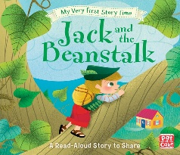  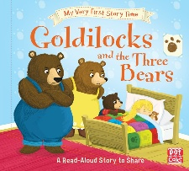  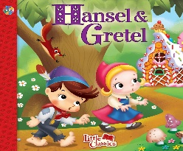  Additional Suggestions  - Nursery rhymes, hey diddle diddle, twinkle twinkle  - The King’s Pants  - The colourful coronation  - The king and the cook  - Dragon post  - The Girl with Two Dads | 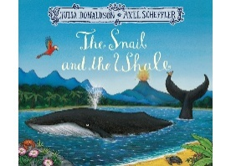  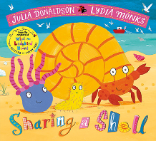  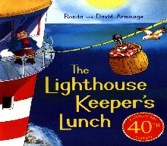  Additional Suggestions  - Caterpillar cake book  - We’re Roaming in the Rainforest  - Monkey Puzzle Who am I?  - Greta and the giants  - Don’t Let Them Disappear  - My little Rainforest Explorers  - Doris the Loris
Word Reading | - Blend sounds to read words  - read short Ditty stories | - Read Red Storybooks
Comprehension | - Fiction is a story or book about imaginary events and characters.  - Non-fiction is a text or book about real facts, people and events. Books often have unfamiliar words in them. | - A story is an account of something that happened that can be true or made up.  - Stories can be retold using simple words and props.  - Demonstrate understanding of what has been read to them by retelling stories and narratives through role play and small world play, using some key vocabular
Opportunities for Mark making/Writing | - Writing simple CVC words containing set 1 sounds  - Use initial sounds to label characters / images.  - Writing Names and Labels.  - Writing messages  - Practising correct letter formation. | - Writing simple CVC words containing set 1 sounds  - Use at least initial sounds to label characters / images.  - Writing first name independently from memory  - Writing messages  - Practising correct letter formation.
Mathematics | WRM Units:  - Alive in 5!  - Growing 6,7,8  Other links:  - Quantity; more and less in different contexts including physical objects such as counters, capacity of containers, money and numbers e.g., how many cubes can fit in this box? Can we fit more in this bigger box? How many more can we fit?  - Numbers within 20; automatic recall of number bonds to 10, secure understanding of numbers between 10 and 20, recognise the value of 10. | WRM Units:  - Building 9 & 10  - Consolidation of Spring term skills  Other links:  - Seasons in a year  - Counting to 20 and beyond i.e., children in a line  - Positional language; games where children move objects around and describe their position.  - Verbally count to 20 and beyond.  - Time to the hour and beyond; make clocks with cardboard and a split pin.  - Addition and Subtraction with numbers to 20 using concrete objects to support  - understanding.  - Odd and even numbers; using concrete objects such as numicon to support understanding.
Understanding the World – UTW
Past and Present - History | - Recognise and begin to talk about how their lives have changed as they have grown.  - Then and Now – Who’s who? What is different? What is the same? How have you changed over time?  - Shops, toys, vehicles from the past  - Looking at different sources i.e., black and white photographs | - Put familiar events in chronological order, using pictures and discussion.  - Encourage use of language relating to time, such as 'first', 'then', 'next' and 'after that' as they talk about their experience and favourite activities from the observations made.
People and Communities – Geography & RE | - All families are special and different. They celebrate different events in different ways.  - Describe ways to look after the immediate environment.  - Discuss how the local environment has changed over time using photographs and first-hand experiences. | - This project teaches children about the global community to which they belong and explores how living things, communities and climates differ around the world.  - Can use a map of the UK and name a seaside.  - Can identify features of a seaside.
The Natural World  - Science | - Change of materials- water turns to ice  - Play dough making  - Baking  - Liquid to solids | - Describe some ways that animals should be cared for in order for them to survive. Features of animals- fur, scales, four legs.  - Seasons of the year: Spring. The first signs of spring; snowdrops, cherry blossom, buds and flowers, birds nesting, bees, lighter evenings
Come and See – Catholic Primary Religious Education Programme | Local Church - Community | Eucharist - relating | - giving
 | - Created to live in community | - How and why people gather together?  - The joy of gathering together to celebrate at mass
Expressive Arts and Design- EAD | - Mixing shades of grey using black and white paint  - Sewing – using buttons and hessian  - Explore, build and play with a range of resources and construction kits with wheels and axles. | - Naming primary colours  - Mixing primary colours  - Fruit and vegetable printing technique
Festivals and Celebrations
Potential Trips/visitors | - A significant person from History talks i.e., Florence Nightingale  - Old Toy/new toy workshop  - Visit a museum | - Visit a farm or  - Mobile farm in to school  - Eggs/frog spawn/caterpillars to show the lifecycle of a living creature
Other special events | - Eid  - St Georges day | - King’s Birthday  - Father’s Day  - Eid Al-Adha

