 | Autumn 1  03.09.25 – 24.10.25  7 weeks and 3 days |  | Autumn 2  03.11.25-19.12.25  7 weeks |  | Spring 1  05.01.26 - 13.02.26  6 weeks |  | Spring 2  24.02.26 – 02.04.26  6 weeks |  | Summer 1  13.04.26-22.05.26  5 weeks and 4 days |  |  | Summer 2  08.06.26 – 17.07.26  6 weeks
CLASS NOVEL  This text will form the basis of writing units. | 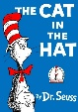  The Cat in the Hat | 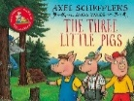  The Three Little Pigs | 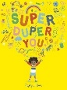  Super Duper You | 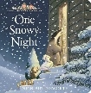  One Snowy Night | 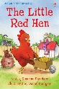  Little Red Hen | 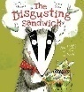  The Disgusting Sandwich | 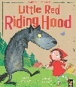  Little Red Riding Hood | 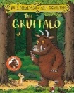  The Gruffalo | 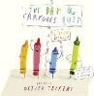  The Day the Crayons Quit |  | 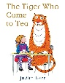  The Tiger who Came to Tea | 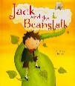  Jack and the Beanstalk | 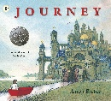  Journey
WRITING UNITS  Imitate, Innovate, Independent | Simple Retell and Innovation  Children learn the text and create innovated dictated sentences. | Simple Retell and Innovation  Children learn the text and create innovated dictated sentences | Simple Retell and Innovation  WAGOLL:  Super Duper You  INNOVATE  Super Duper Me | Poetry  WAGOLL:  Moon poetry  INNOVATE:  Snow poetry | Fiction  WAGOLL:  Little Red Hen  INNOVATE:  Little XXX XXX  INDEPENDENT:  Little XXX XXX | Non-Fiction  WAGOLL:  How to make a disgusting sandwich  INNOVATE:  How we make the class disgusting sandwich  INDEPENDENT:  How I make my disgusting sandwich | Fiction  WAGOLL:  Little Red Riding Hood  INNOVATE:  Little Pink Riding Hood  INDEPENDENT:  Little XXX Riding Hood | Non-Fiction  Writing to recount events  WAGOLL:  The Gruffalo police report  INNOVATE:  Class changes the Gruffalo’s appearance  INDEPENDENT:  Independently change the Gruffalo’s appearance | Fiction  WAGOLL:  Letter from one of the crayons  INNOVATE:  Letter from rainbow crayon  INDEPENDENT:  Letter from rainbow XXX |  | Fiction  Writing to recount events  WAGOLL:  The Tiger who Came to Tea  INNOVATE:  The XXX who came to tea  INDEPENDENT:  The XXX who came to tea | Fiction  WAGOLL:  Jack and the Beanstalk  INNOVATE:  Class innovates who is up the beanstalk  INDEPENDENT:  Independently plan who is up the beanstalk | Fiction  WAGOLL:  The world the girl drew  INNOVATE:  The world the class drew  INDEPENDENT:  The independent world drawn by each child
PUNCTUATION OR GRAMMAR FOCUS | Nouns | Verbs | Personal pronoun ‘I’ | Nouns | Question marks | Verbs | Proper nouns | Plural Nouns  Using s/es | Question marks | Personal pronoun ‘I’ |  | Using ‘and’ | Using ‘and’
PUNCTUATION OR GRAMMAR FOCUS | Simple sentences | Simple sentences | Simple sentences | Adjectives | Verbs | Present tense | Exclamation marks | Adjectives | Proper nouns | Past tense |  | Using ‘and’ | Using ‘and’
WEEKLY SPELLING RULE |  | Double ‘ss’ | ‘y’ ‘igh’ sound | Short ‘a’ vowel | ‘ould’ ‘u’ sound | ‘ph’ ‘f’ sound | ‘a’ ‘or’ sound | ‘ing’ suffix | Days of the Week |  | Suffix ‘est’ | Root words | Revision
WEEKLY SPELLING RULE | ‘th’ | ‘se’ sounds like ‘s’ | ‘e’ long vowel | Short ‘e’ vowel | ‘o’ ‘oo’ sound | ‘wh’ ‘w’ sound | ‘o’ ‘u’ sound | ‘ed’ suffix | Days of the Week |  | Suffix ‘ere’ | Past and present | Revision
WEEKLY SPELLING RULE | Double ‘ll’ | ‘i’ ‘igh’ sound | ‘o’ ‘ow’ sound | Root word ‘add ons’ | ‘o’ ‘u’ sound |  | Prefix ‘un’ |  | ‘ve’  ‘s’ and ‘es’ |  |  | Syllables
WEEKLY SPELLING RULE | ‘s’ sounds like ‘z’ | ‘o’ ‘ow’ sound | ‘ue’ ‘oo’ sound |  | ‘y’ ‘ee’ sound |  | Compound words |  | Suffix ‘er’ |  |  | ‘tch’ not ‘ch’

