 Wraparound Provision Play Policy
Name of Setting: St Joseph’s Catholic Primary School
Location: St Joseph’s Catholic Primary School, Green Lane, Rawmarsh, Rotherham, S62 6JY
Date Adopted: February 2026
Review Date: February 2027
Policy Lead: Christie Williams

Mission Statement

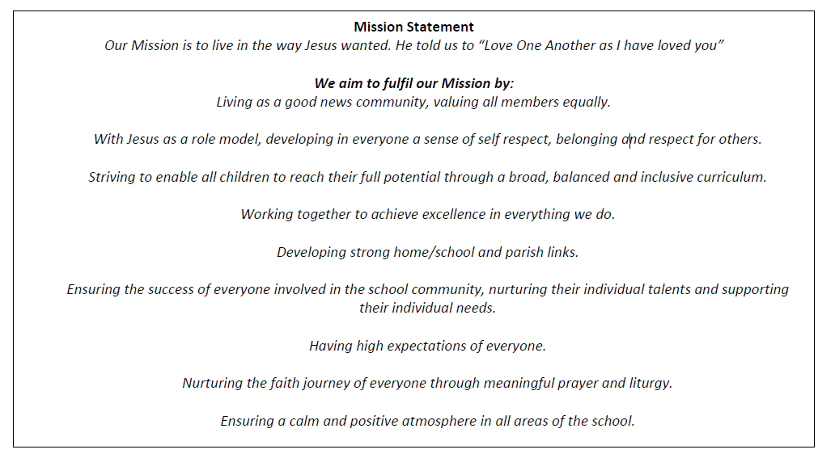

Statement of Intent
At St Joseph’s, we recognise that play is a fundamental part of children’s development, wellbeing, and enjoyment. Our wraparound provision provides a safe, inclusive, and stimulating environment where children can freely choose how they spend their time outside of the formal school day.
We acknowledge the principles of the United Nations Convention on the Rights of the Child (UNCRC), particularly Article 31, which states that every child has the right to rest, leisure and play.
Our provision complements the school day by offering opportunities for relaxation, creativity, social interaction and physical activity in a less structured environment.

Definition of Play
We define play as:
Freely chosen, personally directed and intrinsically motivated activity that children engage in for enjoyment and recreation.
Children determine:
- What they play
- How they play
- Who they play with
- How long they play (within the session structure)

Aims of the Play Provision
Our wraparound provision aims to:
- Provide a safe, secure, and welcoming environment
- Offer a broad range of play opportunities (creative, physical, imaginative, social, quiet)
- Promote independence and decision-making
- Support children’s emotional wellbeing
- Encourage positive relationships and cooperation
- Provide inclusive play experiences accessible to all children

Principles of Playwork
Our practice is underpinned by recognised playwork principles, including:
- Children’s play is freely chosen and self-directed
- Adults support rather than direct play
- Risk in play is balanced and managed appropriately
- The play environment is responsive to children’s interests
Staff act as facilitators, observing and responding to children’s needs while allowing them ownership of their play experiences.

The Play Environment
We provide a rich and varied play environment that may include:

Indoor Play
- Arts and crafts
- Construction toys (e.g. Lego, blocks)
- Board games and puzzles
- Role play areas
- Reading and quiet zones
- Small world play

Outdoor Play
- Ball games
- Climbing and balancing activities
- Scooters or bikes (where appropriate)
- Nature exploration
- Group games
Where possible, children will have daily access to outdoor play.

Planning provision activities
The planning of the wraparound provision is guided by children’s interests, developmental needs, and the principles of play-based practice. Staff use regular observation, pupil voice, and informal discussions to inform a flexible weekly plan that offers a balance of creative, physical, imaginative, social and quiet activities. While a range of optional adult-led experiences may be available, children are free to choose how they spend their time, ensuring play remains freely chosen and child-directed. Planning takes into account the ages and abilities of the children attending, promotes inclusion in line with the Equality Act 2010, and supports wellbeing and safeguarding in accordance with Keeping Children Safe in Education. The provision complements, but does not replicate, the formal school curriculum, instead providing opportunities for relaxation, exploration and social development beyond the school day.
The school has provided staff with a flexible medium-term plan of activities for each half term, designed to give children the opportunity to explore a variety of play areas. These include physical play, creative play, imaginative play, social play, reflective play, exploratory play, and risk/challenge play. Activities are carefully planned across the term to ensure children can engage with all areas of play, and resources are thoughtfully selected to support and enhance these experiences.

Risk and Challenge in Play
We recognise that play may involve elements of risk and challenge, which are essential for children’s development.
We will:
- Carry out appropriate risk assessments
- Supervise appropriately without over-restricting
- Teach children to assess and manage risks themselves
- Maintain equipment safely
We aim to provide a balance between safety and opportunities for children to develop resilience and confidence.

Inclusion and Equal Opportunities
Our provision is fully inclusive and welcomes all children regardless of:
- Race
- Gender
- Disability
- Religion or belief
- Cultural background
- Family structure
We will make reasonable adjustments to ensure children with additional needs can access play opportunities.
This policy operates alongside the school’s Equalities Policy and in line with the Equality Act 2010.

Behaviour and Play
We promote positive behaviour through:
- Clear, consistent boundaries
- Encouraging cooperation and respect
- Supporting children to resolve conflicts independently where appropriate
- Staff modelling respectful communication
Play may sometimes appear loud or energetic; this is not automatically considered poor behaviour. Staff distinguish between play noise and unacceptable behaviour.

The Role of Staff
Staff will:
- Provide a welcoming and relaxed atmosphere
- Observe children’s play and intervene only when necessary
- Ensure safety while respecting children’s independence
- Support children in extending their play
- Encourage inclusion and fairness
- Undertake appropriate training
Staff will not unnecessarily direct or structure play unless a planned activity is clearly offered as optional.

Partnership with Parents and Carers
We recognise the importance of working in partnership with families. We will:
- Share information about the play opportunities offered
- Listen to feedback from parents and carers
- Inform families of any concerns regarding wellbeing or behaviour
- Encourage open communication

Safeguarding
Children’s safety and welfare are paramount. This Play Policy operates alongside the school’s Safeguarding and Child Protection Policy and in line with statutory guidance, including Keeping Children Safe in Education.
All staff are trained in safeguarding procedures and understand their responsibilities.

Monitoring and Review
This policy will be reviewed annually or sooner if:
- Legislation changes
- Guidance is updated
- Practice developments require revision
Children’s views will be considered as part of the review process.

Conclusion
Our wraparound provision values play as a vital and enriching part of children’s daily lives. By providing a safe, inclusive and stimulating environment, we support children to relax, explore, create, and develop essential life skills beyond the formal school day.

Date of approval: February 2026
Date of renewal: February 2027
Headteacher:
Chair of Governors:

